Communicating with Emotional Intelligence

Communicating with emotional intelligence allows us to practice empathy, boost stronger working relationships, and learn from and value co-workers. But how does one communicate with emotional intelligence?
“It is very important to understand that emotional intelligence is not the opposite of intelligence, it is not the triumph of heart over head — it is the unique intersection of both.” – David R. Caruso, Emotional Intelligence Skills Group cofounder

What are the Benefits of Communicating with Emotional Intelligence?
- Reduces conflicts
- Builds better relationships
- Enhances job performance
- Prevents reacting impulsively
- Improves quality of teamwork
- Encourages thought-out decisions
- Lays the foundation for well-equipped future leaders
- Cultivates clear, concise, and authentic communication

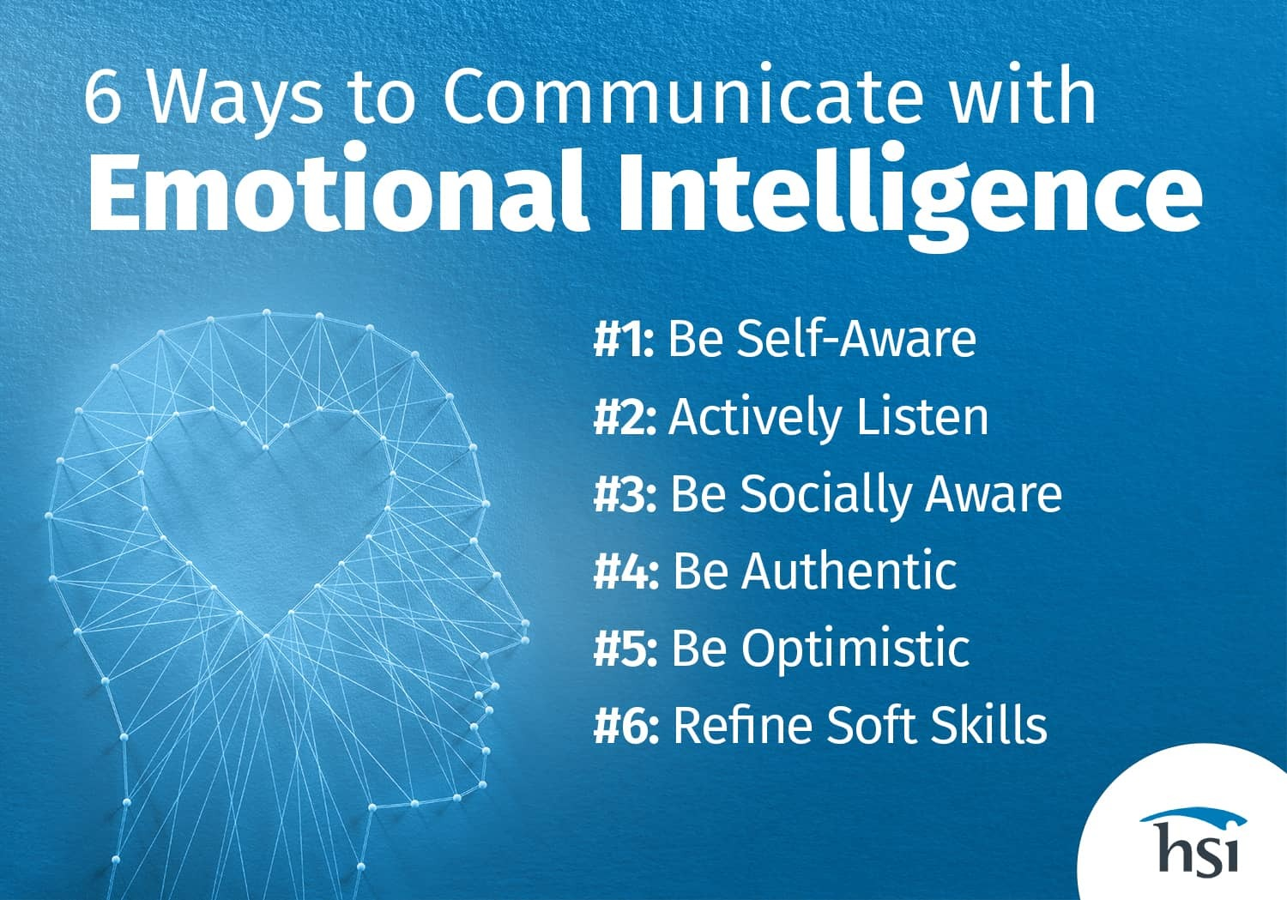

6 Ways to Communicate with Emotional Intelligence
In today’s world, because cross-cultural team members are globally dispersed and span more generations than ever before, the complexities of interactions and how communications are perceived and expressed are substantially magnified. Communicating with emotional intelligence is more important than ever.
Effective communication involves being clear, direct, and concise in our messaging, actively listening, and adapting communication styles to fit the needs of the situation. Emotional intelligence is an important key skill that builds effective relationships. It also affects the quality of work we produce and the relationships we build as team members. Communicating with emotional intelligence lays the foundation for future business leaders who are well-equipped to face communication challenges. Here are 6 different ways to communicate with emotional intelligence:
#1: Be Self-Aware
Being self-aware is the highest level of emotional intelligence and involves regulating our emotions and being able to respond to the emotions of others in a professional manner. Relationships in the workplace are affected by how we manage our own emotions and our understanding of the emotions of those around us. Ineffective communication or lack of open, authentic discussion can lead to resentment, frustration, conflict, misunderstanding, anxiety, uncontrolled stress, burnout, and affect overall well-being. The ability to be self-aware impacts communication capabilities in both one’s personal and work life. Being self-aware is the first step toward building emotional intelligence.
Here are several tips for how to build self-awareness:
- Reflect on your values and beliefs.
- Be realistic about your strengths and areas of improvement.
- Have high self-regard and self-acceptance, regardless of faults.
- Know how you’re perceived by others.
- Manage emotions by knowing your triggers – the events, people, or difficult situations that cause you to have strong emotional reactions. Without knowing what triggers an emotional reaction, it’s easy to react impulsively. When we know what our triggers are, we can recognize them during stressful situations and then choose to slow down and take a deep breath before responding. We’re then more able to choose words wisely to continue the conversation and bring it to a productive end. These simple techniques prevent reacting impulsively, overreacting, offending, and hurting the other person.
Ways to strengthen one’s EQ in self-awareness:
- Practice mindfulness. Be fully aware of your thoughts and feelings in the present moment.
- Name the emotions. (happy, grateful, sad, angry, frustrated, etc.) you are feeling at that moment.
- Learn impulse control to resist an impulse to act when it’s unhelpful or unhealthy.
- Practice emotional flexibility to transition emotions from one state to another.
- Practice emotional regulation by being mindful and taking control of thoughts and actions in a healthy and positive way at work.
- Rather than being upset at a co-worker, calmly offer feedback instead of lashing out; check your emotions to be sure they’re appropriate for the setting before responding to an email.
- Always remember to stay composed. Avoid using aggressive language. Take deep breaths and approach the conversation with an open mind.
- Use “I” statements. Such as, “I feel frustrated when I don’t have all the facts to move forward on a project.”
- Use constructive, proactive language like, “I think we can improve if we follow this new process.”
“When awareness is brought to an emotion, power is brought to your life.” – Tara Meyer- Robson, award-winning author and mind-body-life translator

#2: Actively Listen
Active listening is being fully present. This will keep conversations focused and on-point. By doing so, we can understand others on a deeper level and reach more favorable outcomes.
The benefits of actively listening are many – from building stronger relationships through trust and respect to showing we value others’ perspectives and experiences. This then encourages others to be open as well.
Here are several tips on how to actively listen:
- Pay full attention to what the other person is saying.
- Do not interrupt or judge.
- Ask clarifying questions.
- Read facial expressions and non-verbal communication.
- Be mindful of tone of voice and body language, as these nonverbal cues tell more than what the person may or may not vocalize.
- Maintain eye contact. This shows sincerity, respect, and empathy.
- Sit up straight. This shows confidence and interest. If someone is slouching, they could be bored or showing signs of avoidance.
- Nodding your head in agreement and other positive body language tells others we’re actively listening.
Ways to strengthen one’s EQ in actively listening:
- Try to understand others’ emotions. The emotions one perceives can have a variety of meanings. Does an employee’s silence mean too many approaching deadlines or is it unrelated to work?
- Be empathetic. For example, “I appreciate all your well-thought-out recommendations, I noticed you are quiet in meetings recently, is everything ok?”
- A critical skill directly linked to communicating with emotional intelligence is the ability to read facial expressions and non-verbal communication then learn to react or respond in a positive way. Aligning your intentions with your nonverbal communication is part of the emotional intelligence communication process.
#3: Be Socially Aware
Social awareness is the ability to take the perspective of and empathize with others, including those from diverse backgrounds and cultures. Being socially aware is important when it comes to motivating and engaging others.
Here are several tips on how to be socially aware:
- Make a conscious effort to get to know co-workers.
- See others’ perspectives.
- Be curious. Ask open-ended questions.
- Listen carefully to the other person’s responses.
- Be empathetic. Use a sympathetic tone of voice and display positive nonverbal communication.
Ways to strengthen one’s EQ in social awareness:
- Put oneself in someone else’s shoes and imagine how they feel in the situation.
- Visualize oneself as an observer in a stressful work situation and pay close attention to how others are impacted.
- As a leader, if a direct report is struggling, ask if they can pinpoint why they are having difficulty. Then provide more detailed guidance and training, if necessary, based on their feedback.
- When receiving feedback, don’t immediately dismiss it if it doesn’t align with your thinking.
- Listen to others’ points of view but then don’t muddy what they are saying to support your agenda. If one does so, they’re not communicating with emotional intelligence or building trust.
- Become more open and adaptable to others’ views and suggestions.
- Be more empathetic.
- When communicating with emotional intelligence we must understand how others are feeling and understand their values and beliefs.
- Strengthen communication skills and learn how to hold purposeful and meaningful conversations.
- Make it a practice to respond by saying, “tell me more about that.”
- Listen for valuable feedback and learn. This can be a great way to make process improvements, for example.
- Be sure to always acknowledge and affirm.
- Say, thank you. For example, “Thank you, we value your opinion, this is why the company is proceeding in this manner.” This way, employees feel heard and understood, even if their suggestions are not implemented. They will be more inclined to support the decision as valuable time was spent listening and explaining the reasoning behind the decision.
#4: Be Authentic
Authenticity is being true to your personality, beliefs, and values regardless of the pressure to act otherwise. When we’re more transparent, we become more effective communicators and express ourselves better.
Here are several tips on how to be authentic:
- Be true to yourself.
- Be open and honest. “Say what you mean and mean what you say.”
- Set healthy boundaries.
- Ask for help when needed.
- Assert how you feel and what you need in a clear, respectful, and professional manner.
Ways to strengthen one’s EQ in being authentic:
- Learn to be more assertive.
- Practice saying what needs to be said in a non-offensive way and when the time is right.
- Practice saying no when needed in a way that is professional and socially aware.
#5: Be Optimistic
Optimism is hopefulness and confidence about the future or a successful outcome. Communication will flow easier and be more productive when the future is brighter, and team members feel a sense of positive outcomes.
Here are several tips on how to be optimistic:
- Express gratitude.
- Appreciate co-workers. Strong beneficial working relationships will develop.
- View challenges as learning experiences.
- See the silver lining in setbacks.
- Read HSI’s blog, Positive Thinking Exercises for the Workplace.
Ways to strengthen one’s EQ in optimism:
- Practice self-discipline. Refine the ability to control emotions and reactions, even during stressful times. Staying positive in the face of challenges and viewing obstacles as opportunities keeps the focus on an optimistic future.
- Practice positive reframing. Changing our perspective is a great first step to minimizing overly emotional responses.
- Ask yourself questions like, “What type of stress is causing them to be so short?” or “Are they feeling overwhelmed and taking it out on me?”
- These questions open one’s mind to the possibilities concerning what this co-worker is facing. It helps us respond from a place of support and optimism instead of conflict and negative feedback.
#6: Refine Soft Skills
Soft skills are sets of abilities that reflect how well a person gets along with others around them and how well they’re able to identify and address problems. When one thinks about soft skills training topics, what comes to mind? Listening. Coaching. Feedback. Collaboration. Conflict Management. Resilience. What do all of these have in common? Communication and emotional intelligence!
Research shows successful communication and negotiation are closely linked to high levels of EQ. People with low levels of EQ may react defensively in stressful situations and cause conflict. Individuals with higher EQ have refined the skills needed to be able to communicate effectively without confrontation or anger.
Employees with higher EQ are more likely to approach conflict resolution collaboratively. They will work with other employees to reach a mutually acceptable outcome.
These skills don’t always come naturally but they can be taught. And everyone has room to improve. Taking soft skills training will help strengthen employees’ communication and EQ skill sets.

The Relationship Between Emotional Intelligence and Effective Communication
Communication isn’t just about the words we say. It’s also about understanding the emotions behind those words. Emotional intelligence allows us to perceive and understand these emotions, leading to more effective and meaningful communication. When we understand our own emotions, we can express our feelings and thoughts more clearly. When we understand the emotions of others, we can respond to their needs more effectively.
Strategies for Using Emotional Intelligence to Improve Communication Skills
So, how can you use emotional intelligence to improve your communication skills? Here are some strategies:
- Practice self-awareness. Pay attention to your own emotions. Recognise how they influence your thoughts and actions.
- Develop empathy. Try to understand the emotions of others. Put yourself in their shoes and consider their perspective.
- Manage your emotions. Don’t let your emotions control your actions. Learn to respond, not react.
- Improve your listening skills. Listening is a crucial part of communication. Listen to understand, not just to respond.
- Use emotional language. Express your feelings using emotional language. This can help others understand your perspective.
- By mastering these strategies, you can improve your communication skills and build stronger, more meaningful relationships.

